

CS 319

**Object-Oriented Software Engineering  
Fall 2014**

**USER GUIDE**

**GROUP G**

**Cansu Tüzmen**

**Doğancan Demirtaş**

**Günçe Kalyoncu**

**Erkut Alakuş**

**Table Of Content**

**1.Introduction**

**2.System Requirements and Launch Configurations 4**

**2.1. System Requirements 4**

**2.2. Launch Configurations 4**

**3.Gameplay 5**

**3.1. Game Overview 5**

**3.2. Game Menus 5**

**3.2.1.Main Menu 5**

**3.2.2. Settings 6**

**3.2.3.High Score List 6**

**3.2.4.How To Play 7**

**3.2.5.Credits 8**

**3.2.6.Exit 8**

**3.2.7 Pause Menu 9**

**4.Game Objects 9**

**4.1. Miner 9**

**4.2. Earth Monster 10**

**4.3. Gold & Silver 10**

**4.4. Bonus 11**

**4.5. Life 12**

**4.6. Controllers 12**

**4.7. The Maze 13**

**1.Introduction**

Digger Unlimited is a developed and modified version of Digger that is a basic arcade game like *Pac-man* and *Dig Dug*. As in those games, the main aim is that collecting all gold and silvers without being caught by the monsters to finish the level. Unlike the original version, the Digger Unlimited will include new features like bonuses to make it more entertaining.

**2.System Requirements and Installation**

**2.1. System Requirements**

* JAVA SE8 is required.
* Windows 2000/XP/7/8 or Mac OSX+
* Screen resolution must be at least 1366x768 p.

**2.2. Launch Configurations**

All DiggerUnlimited.jar, images, music files and map.txt file should be in the same folder. The players can simply open the game by running the DiggerUnlimited. jar file.

**3.Gameplay**

**3.1.Overview**

Basically, the game starts in a mine and there is a tunnel for the Miner and the Earth Monster to move. There is also some gold and silver for scoring and bonuses for changing the course of the game. The main goal of the player is expanding the existing tunnel by digging to collect all the stuff without being touched by these monster to complete the level successfully.

**3.2.Menus**

**3.2.1. Main Menu**

When the player runs the game,the Main Menu screen is opened and player could easily reach the other menus and play the game by it.

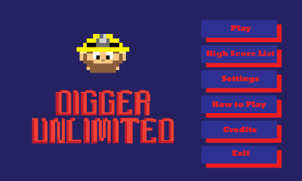

Figure 1 Main Menu screenshot

**3.2.2. Settings**

In order to change sound settings of the game, player should click on Settings button. The player could turn off both music and game sounds.

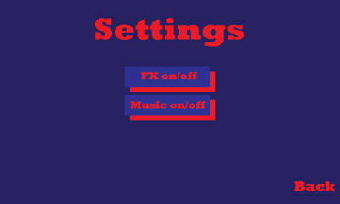

Figure 2 Settings Menu screenshot



Figure 3 Settings Menu screenshot after clicking on Music on/off button

**3.2.3. High Score List**

When the players clicks on High Score List button on the Main Menu this screen will be opened to show scores.



Figure 4 High Score List screenshot

**3.2.4. How To Play**

The player could easily learn how to play the games and its tools by clicking on How to Play button and this screen will show up to show it tools and objects.

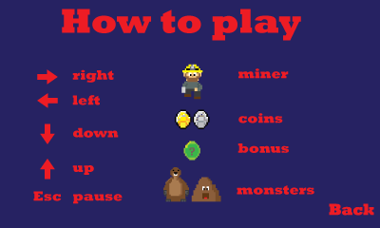

Figure 5 How To Play Menu screenshot

**3.2.5. Credits**

When the players click on Credits button on the mian menu, the screen which includes information about deveopers will be opened .

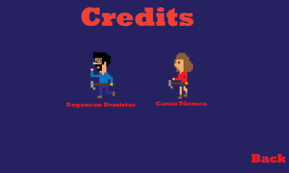

Figure 6 Credits menu screenshot

**3.2.6. Exit**

In order to stop the game, players could click on Exit button.

**3.2.7. Pause Menu**

If players wants to pause the game ,they should press Esc button.

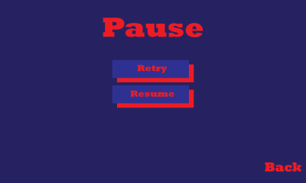

Figure 7 Pause menu screenshot

**4. Game Objects**

**4.1. Miner**



Figure 8 Miner

The hero of the game is Miner. The player should lead him to collect all gold and silver by direction buttons without caught by Earth Monster.

**4.2. Earth Monster**



Figure 9 Earth Monster

The enemy of the Miner is Earth Monster. It follows Miner to kill him. It could not dig like Miner so it moves on the digged path.

**4.3. Gold & Silver**

**C:\Users\Cansu\Desktop\cs319\oyun\gold.pngC:\Users\Cansu\Desktop\cs319\oyun\silver.png**

Figure 10 Gold & Silver

If the players want to increase their score, the should collect these coins as much as possible. A gold gains player 100 point and silver gains 50 point.

**4.4. Bonus**

C:\Users\Cansu\Desktop\cs319\oyun\bonus.png

Figure 11 Bonus

In order to increase the number of lives or the score, the players should try to collect bonuses.

**Extra Life**: it gains players an extra life.

**Lose Life:** it takes one of the life of Miner.

**Gold To Silver:** it changes the score of gold to silver.

**Silver To Gold:** it changes the score of silver to gold.

**Double Gold:** it multiplies the score of it by two.

**Double Silver:** it multiplies the score of it by two.

**Triple Gold:** it multiplies the score of it by three.

**Triple Silver:** it multiplies the score of it by three.

**4.7.Life**

C:\Users\Cansu\Desktop\cs319\oyun\Life.png

Figure 12 Life

At the beginning of the game Miner has 3 lives and if he is caught by Earth Monster he lost one of it and when it equals to zero, game is over.

**4.6. Controllers**

The player could lead Miner by using direction button and pause the game by Esc button.

Right

Left

Down

Up

**4.7. The Maze**

At the beginning of the game, the maze has a labyrinth for both Monster and Minner. The players should dig to collect gold and silver so this labyrinth extends and Monster’s movement area increases. Moreover, the players could follow their number of lives and score from the screen.

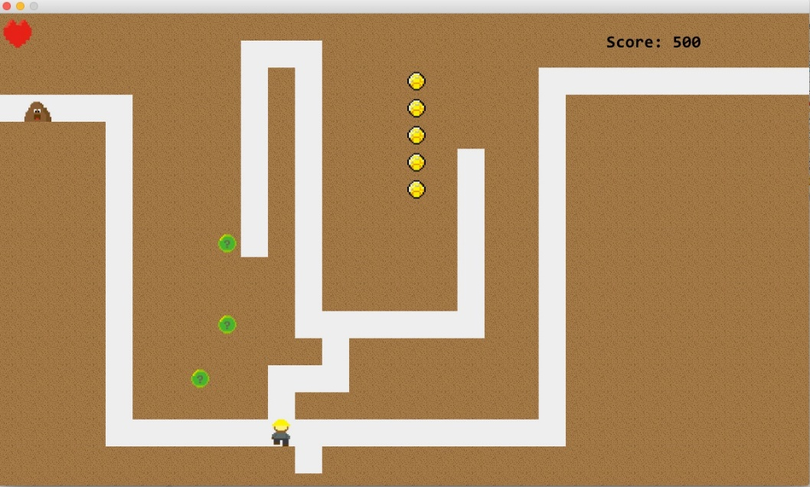

Figure 13 the Maze screenshot